PROJECT TITLE

# PET PARADISE

Submitted in partial fulfilment of the requirements of

PG Diploma

in Advanced Computing

by

Aniket Shinde 210910120027

Vaishali Kele 210910120036

Rupesh Malik 210910120022

Twinkle Dhake 210910120035

Guide:

Ms. Vishakha Kabasi



Centre for Development of Advanced Computing

ACTS Delhi

September 2021

## CERTIFICATE

This is to certify that the project entitled “PETPARADISE” is a Bonafede work of “Aniket Shinde (210910120027), Vaishali Kele(210910120036), Rupesh Malik(210910120022),Twinkle Dhake(210910120035)” submitted to ACTS CDAC Delhi in partial fulfilment of the requirement for the award of the Post Graduate Diploma in Advanced Computing.

Signature: _______________

Name: _______________

(Project Guide)

Signature: Signature:

_______________ ___________________

Name: __________________ Name: ___________________ (Internal Examiner) (External Examiner)

## DECLARATION

I declare that this written submission represents our ideas in our own words and where others' ideas or words have been included, we have adequately cited and referenced the original sources. We also declare that we have adhered to all principles of academic honesty and integrity and have not misrepresented or fabricated or falsified any idea/data/fact/source in my submission. We understand that any violation of the above will be cause for disciplinary action by the Institute and can also evoke penal action from the sources which have thus not been properly cited or from whom proper permission has not been taken when needed.

-------------------------------------------

Aniket Shinde 210910120027

-------------------------------------------

Vaishali Kele 210910120036

-------------------------------------------

Rupesh Malik 210910120022

-------------------------------------------

Twinkle Dhake 210910120035

-------------------------------------------

**TABLE OF CONTENTS**

Abstract

1.0 Introduction

1.1 Purpose

1.2 Scope

1.3 Problems Domain

1.4 Solution Domain

1.5 Platform Specification

2.0 System Requirement Analysis

2.1 Information Gathering

2.2 System Feasibility

3.0 System Analysis

3.1 Use Case Diagram

3.2 Project Architecture

3.3 Component Diagram

3.4 Sequence Diagram

3.5 Collaboration Diagram

3.6 Class Diagram

4.0 Design

4.1 Data Dictionary

4.2 ER Diagram/Object Diagram

4.3 Table Structure

5.0 Implementation

5.1Implementation of Modules

5.2 Graphical User Interface

6.0 Testing

6.1 Unit Testing

6.2 Integration Testing

6.3 Validation Testing

6.4 Test Cases

6.5 Objectives

6.6 Description

7.0 Future Scope

8.0 Conclusion

9.0 References

**Abstract:**

“An animal has not much mind than the human, but they have a loving heart and loyalty.”

Pet keeping is a common part of many cultures. Humans have been sharing their lives with animals from time immemorial. According to research, pets can have a profound effect on us. Interacting with a pet that behaves properly can have a positive effect on you and the people around you.

In our project, we are designing a platform for all the animals and animal lover. One can buy and sell the pet online in trusted hand. For the homeless animals, one can contact to nearby animal shelter will take care of those animals. Doctor, trainer and caretaker contact, and details have also been provided to take care of their pet.

**1. INTRODUCTION**

The project involves designing of a website which would deal with the buying and selling of pets between various users of the website and also the services like animal shelter, pet caretakers, pet trainers, pet veterinaries would be available for the user on one platform. This platform is basically an online shopping system designed for pets and pet lovers. With the help of this web portal users would be able to buy or sell pets such as dogs, cats, birds (like parrots, eagles, pigeons) etc.

**1.1. Purpose**

Our project aims at creation of a user-friendly online buying and selling of the pets while users will also able to tap onto the services like animal shelter, pet caretakers, pet trainers, pet veterinaries on one single platform. This particular system has been designed for pets and pet lovers. This will not only help everyone to gain lucrative benefits but will also help them interact with each other and develop congenial relations.

**1.2. Scope**

This Scope of this project is to provide an all-in-one efficient platform where user can get contacts of animal shelter, pet trainers, pet caretakers, pet veterinary, and primarily they can buy and as well as sell their pets online This system provides user friendly interface resulting in knowing each and every usability features of the system. Also this system provides high level of security for data leaking as only administered people can access the database no changes can be made in it until it verifies the user login id and password. It is a web platform meaning the system will be available for access 24/7 except when there is a temporary server issue which is expected to be minimal.

**1.3 Problem Domain**

The main problem which pet lovers faced nowadays is how to sell their beloved pet’s litters or how to contact veterinary for their health or how to find trainers to train their pets or how to find pet caretakers to care for their pets for some time in the absence of the owners or how to find the contact details of nearby animal shelter in case they find any animal on street that might need the help.

**1.4 Solution Domain**

In order to overcome the above problem this website has been designed which will help pets and pet owners to interact with other pet lovers by selling and buying pets of their requirement without taking much stress. Users can buy pets at reasonable rate(sometimes even lower than the market price)and save money and time. while also having the access to the services like animal shelter, pet caretakers, pet trainers, pet veterinaries on one single platform.

**1.5 System Requirements**

**1.5.1 Hardware Requirements**

* Intel i3 processor 3rd generation or later / AMD Ryzen 200 2nd generation or later
* 2 GB ddr3 ram.
* Windows 7 Home edition or later.
* 200 GB Sata HDD Space
* Data Connection 200 kbps

**1.5.2 Software Requirements**

* Client on Internet: Web Browser, Operating System (any).
* Internet Connection: (any).
* Web Server: TOMCAT, Operating System (any).
* Data Base Server: MySQL, Operating System (any).
* Development End: Eclipse (J2EE, Java, hibernate, spring-boot), MySQL, OS (Windows).
* Designing End: REACT (CSS, BOOTSTRAP5, HTML, JS).

**2. SYSTEM REQUIREMENT ANALYSIS**

**2.1 Information Gathering**

The user has given various requirements for the software project; these include create an online buying and selling system which should include the features of buying and selling pets by displaying pets available to buy then communicating with the users just like olx, and the contact details of animal shelter, pet caretakers, pet trainers, pet veterinaries on one single platform. The home page will roughly show the pets available to buy while at the navbar the links to the service like animal shelter, pet caretakers, pet trainers, pet veterinaries and a login facility and a sign up option will be given and at the footer include the description of website, contact us option, the links to the social media platform.

The customer can view the pets available to buy if and only if he is logged in and if the user wishes to sell his pet then he need to register himself as a seller so then he can add his pet the website for selling purpose.

**2.1.1 Functional Requirements**

Functional requirements are those which specify what a system should do.

* User will login to the portal or will have to register if he is not a registered user.
* After registration User will login and Dashboard page will be displayed to him which will display The Status.
* In the User wants to Sell a pet he can Add his pet details in to the pet registration page
* And the all details will render or display to the buy Page where other user will be seeing all the updated pets
* Where if you want to buy a pet in that case you have to register first then you have to login and you can buy a pet.
* For other services like pet care, pet trainer, pet veterinary, animal shelter you have to register you can use the services.

**2.1.2 Non-functional Requirements**

Those requirements which are not the functionalities of a system but are the characteristics of the system are called non-functional requirements.

* Secure access of confidential data with the use of encryptions.
* Full time available.
* Data Consistency.
* Data Reliability.
* Better component design to get better performance at peak time.
* Flexible service based on architecture will be highly desirable for future extensions.

**2.2 System Feasibility**

**2.2.1 Technical Analysis**

* It is the study of configuration of the system. It considers the technical requirements of the project.
* We have used Eclipse as the developer tool and Spring MVC and Hibernate to develop the project.
* For storage of data in databases we have used MySQL.
* For the Frontend we have used React (CSS, html, JavaScript)**.**

**2.2.2 Operational Feasibility**

It is dependent on human resources available for the project. This application will be able to handle the buying and selling process efficiently. This application will save time and provide an all-in-one platform to the users. It is secure, time saving and allows users to access the website even from remote locations.

**3. SYSTEM ANALYSIS**

**3.1 Use-case Model:**

**Use Case flow Diagram (User):**

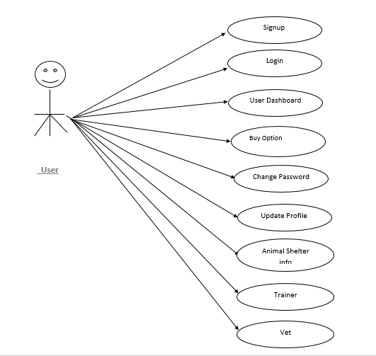

**Use Case flow Diagram (Buyer):**

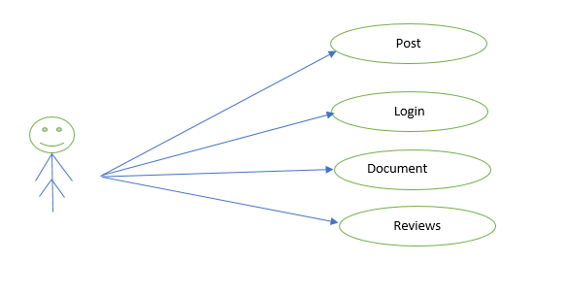

**Use Case flow Diagram (Seller):**

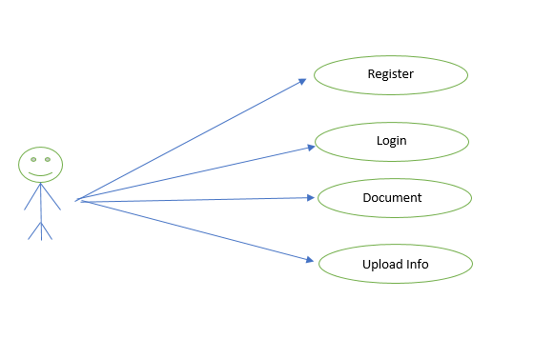

**3.2 Project Architecture:**

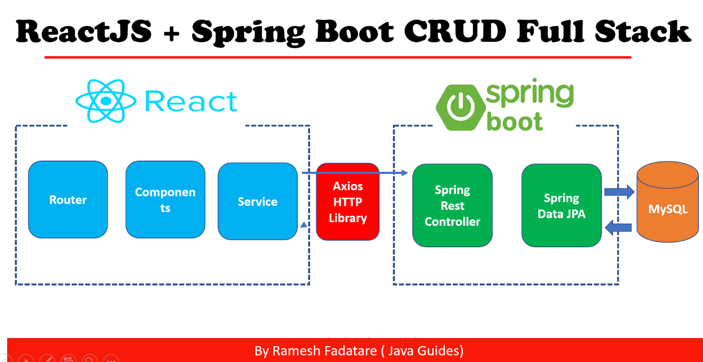

**3.3 Component Diagram:**

Register

Home Page

User Login

Sell

Buy

Add pet

Buy Pet

**3.4 sequence Diagram**

HOME

Animal Shelter

Sign In

Pet Veterinary

Buy

Sign Up

Pet Caretakers

Pet

Trainers

View All Pets

Seller Dashboard/Buyer Dashboard

Buy Pets

Add Pet or

View your added Pet /

View pet for Buyer

**3.5 Collaboration Diagram:**

**1.Login**

**2. Logout 3. Buy/Sell**

* 1. **Class Diagram**

Animal shelter

-id

- shelterName

-address

-phone

Component Status

1.Regstration

2.Pet

3. Pet caretakers

4. Animal shelter

5. Veterinary

6. Trainer

Registration

-id

-adharno

-email

-fname

-lname

-password

-phone_no

-username

-usertype

Veterinary

-id

-vatName

-hospitalName

-address

-phone

Trainer

-id

- trainnerName

-trainningCenterName

- address

-phone

- description

Pet

-id

-age

-bread

-color

-gender

-petname

-price

-Status

-type

-rt-id

-b-id

Pet caretakers

-id

- caretakerName

- careCenterName

- address

- phone

- description

**4. DATA DESIGN**

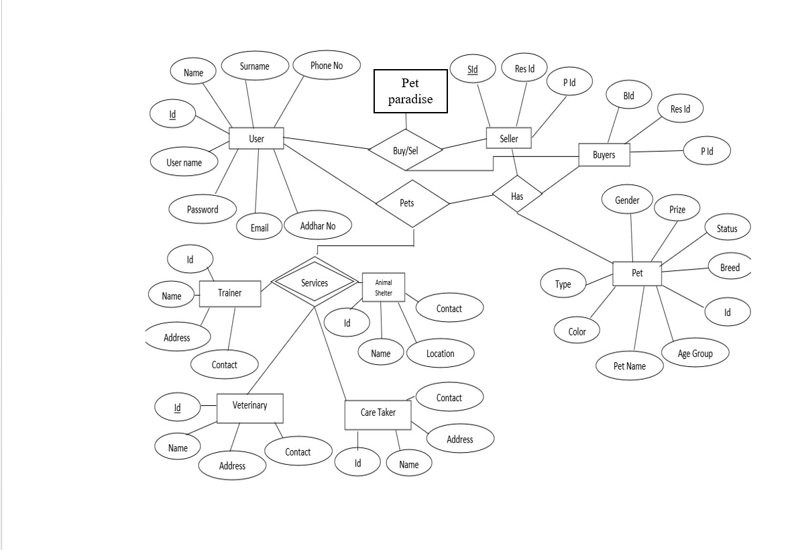

**4.2 ER-diagram:**

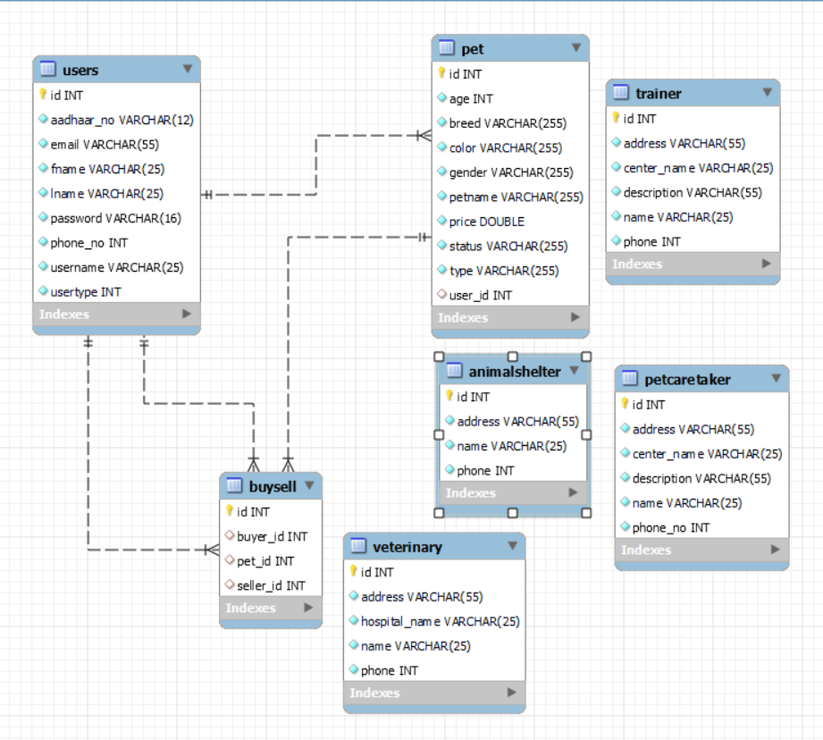

* 1. **Table Structures:**

1. **Table Name: user**

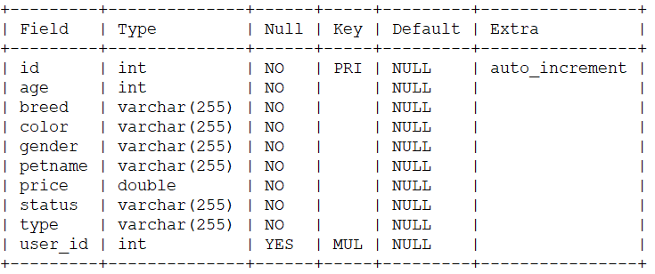

1. **Table Name: pet**

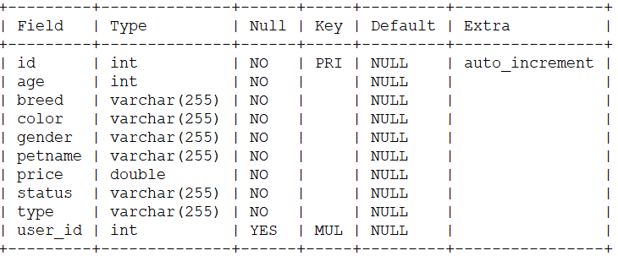

1. **Table Name: petcaretakers**

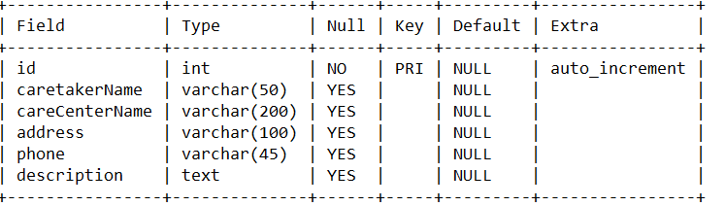

1. **Table Name: animalshelter**

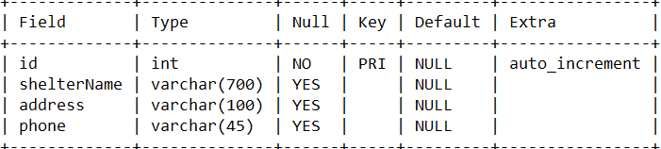

1. **Table Name: veterinary**

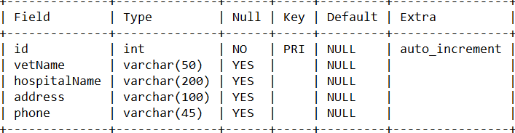

1. **Table Name: trainer**

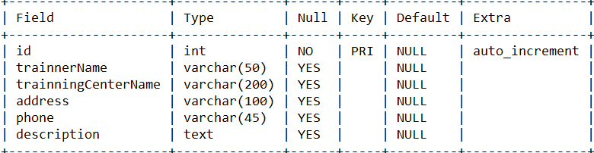

1. **Table Name : buysell**

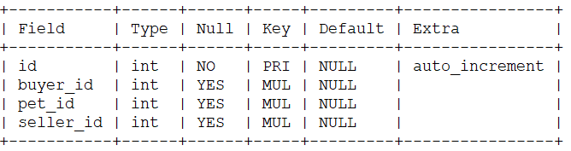

**5.0 IMPLEMENTATION:**

**5.1 Graphical User Interface:**

**5.1.1 Home Page Interface:**

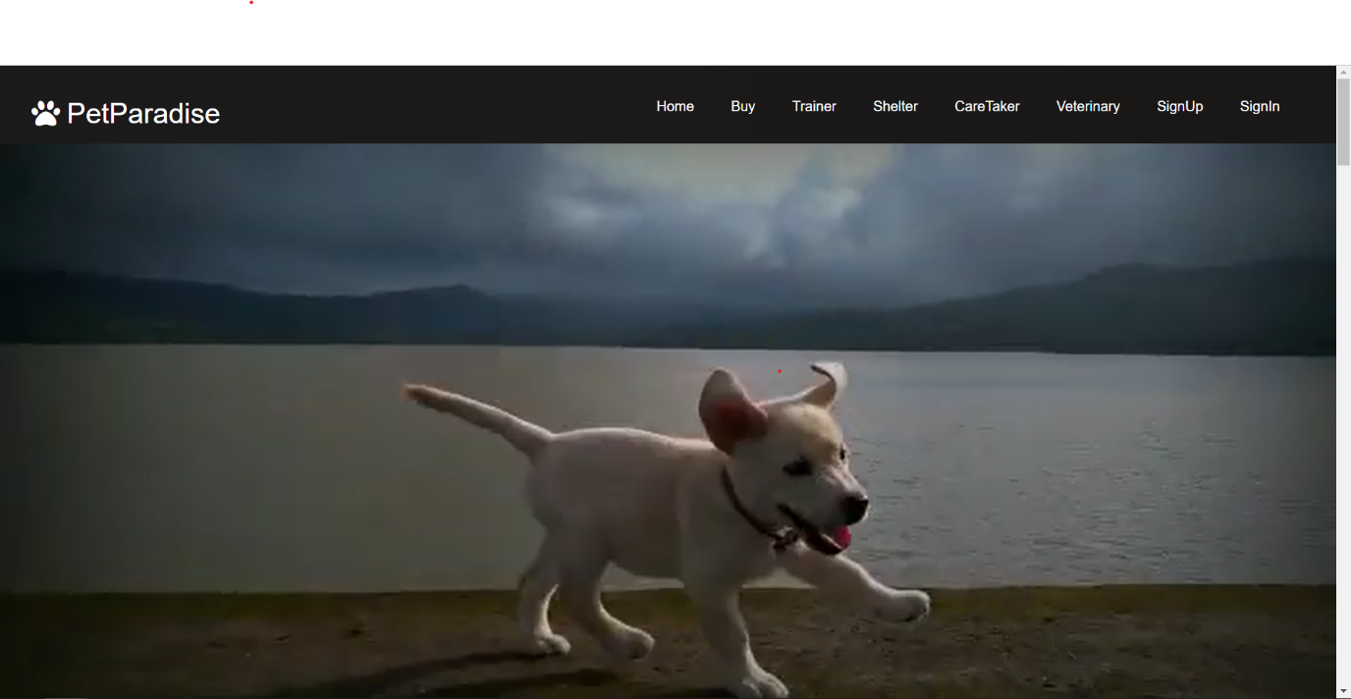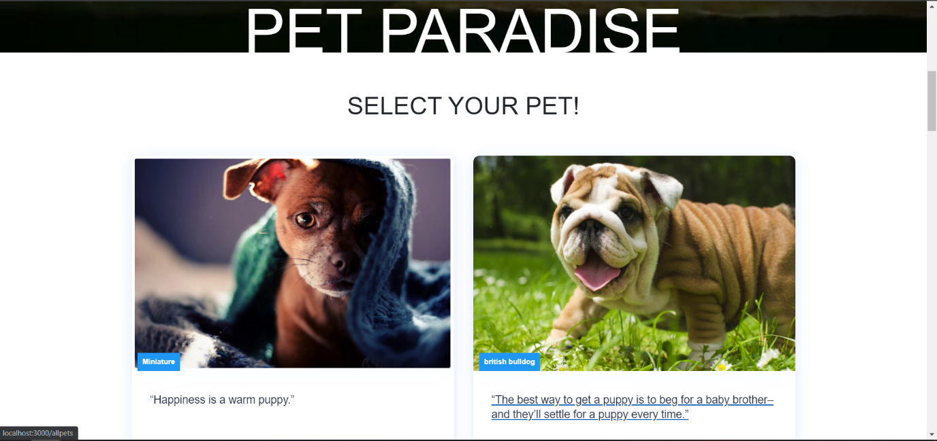

**5.1.2 Login Page Interface:**

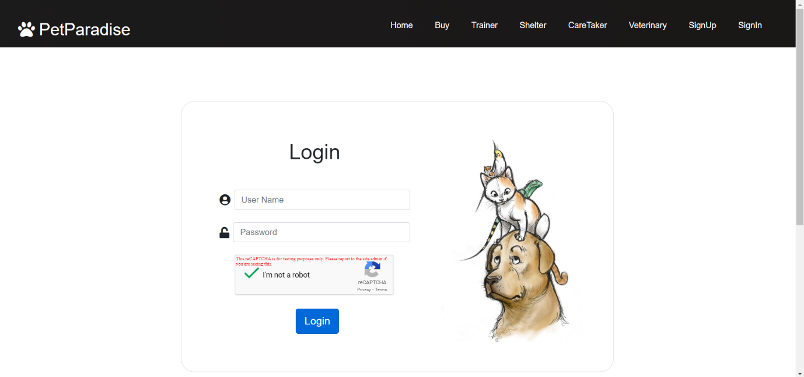

**5.1.3 Registration Page Interface:**

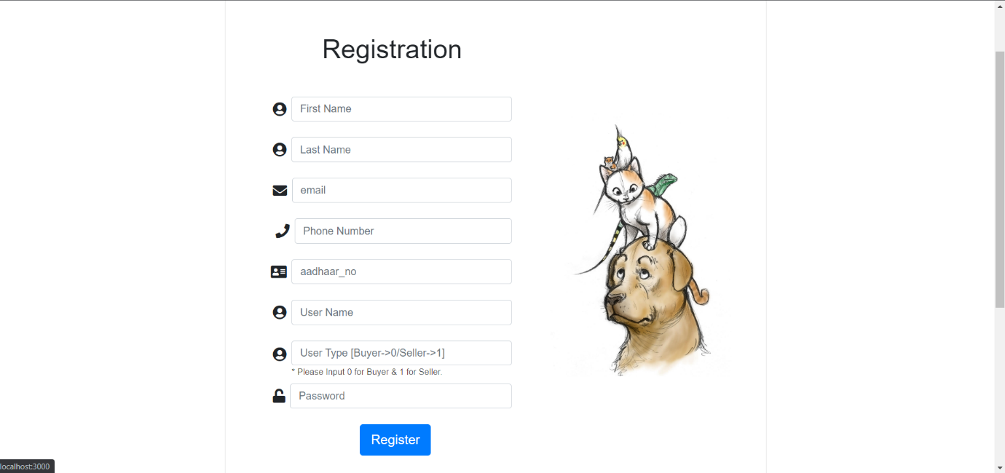

**5.1.4 Buyer Profile Interface:**

**Buyer Profile**

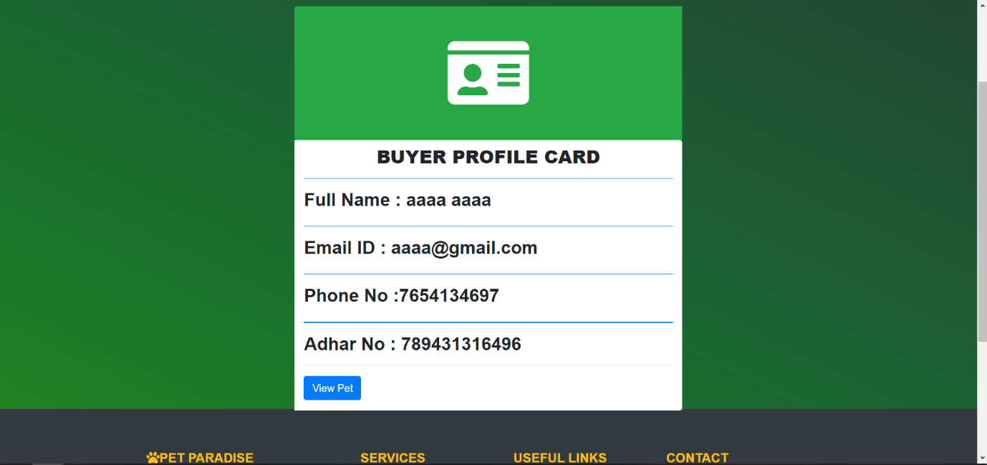

**Buyer Cart**

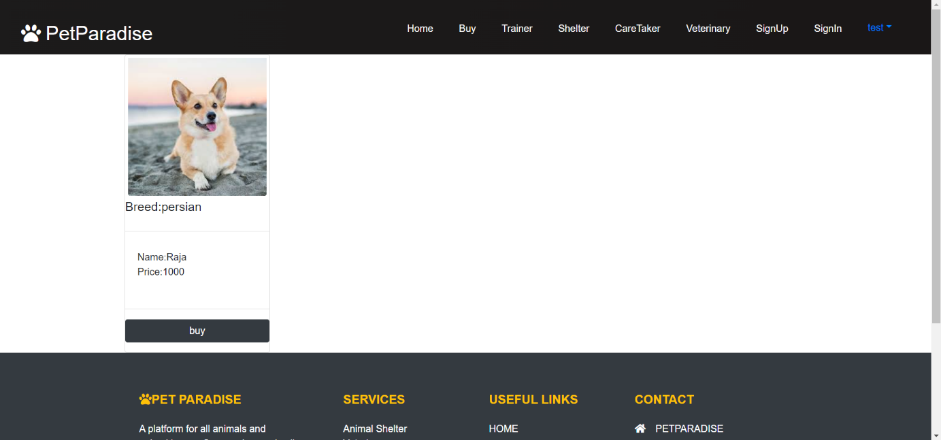

**5.1.4 Seller Profile Interface:**

**Seller Profile**

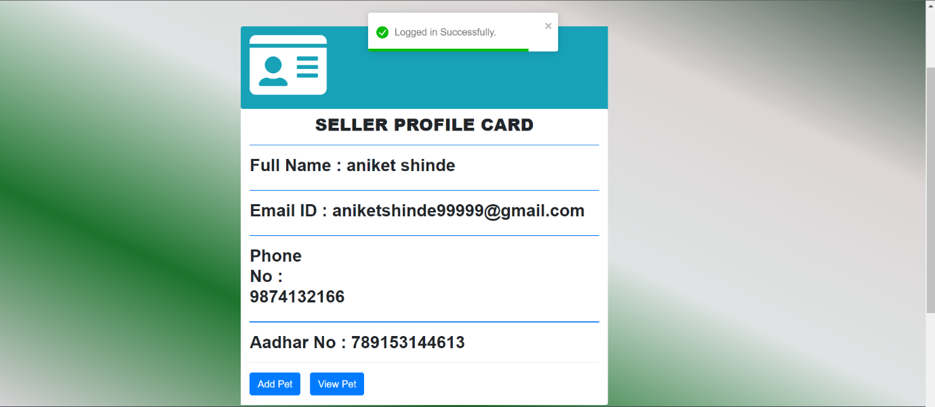

**Add Pet**

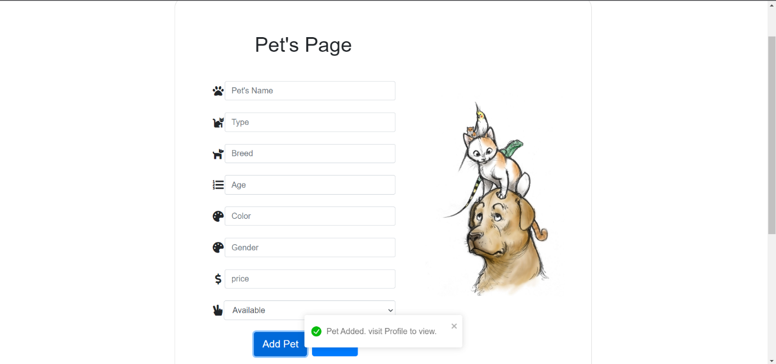

**5.1.5 NAVBAR:**

**5.1.5.1 Buy Interface:**

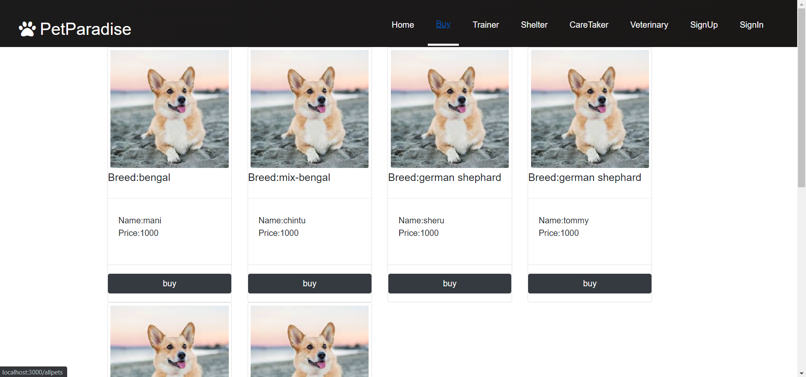

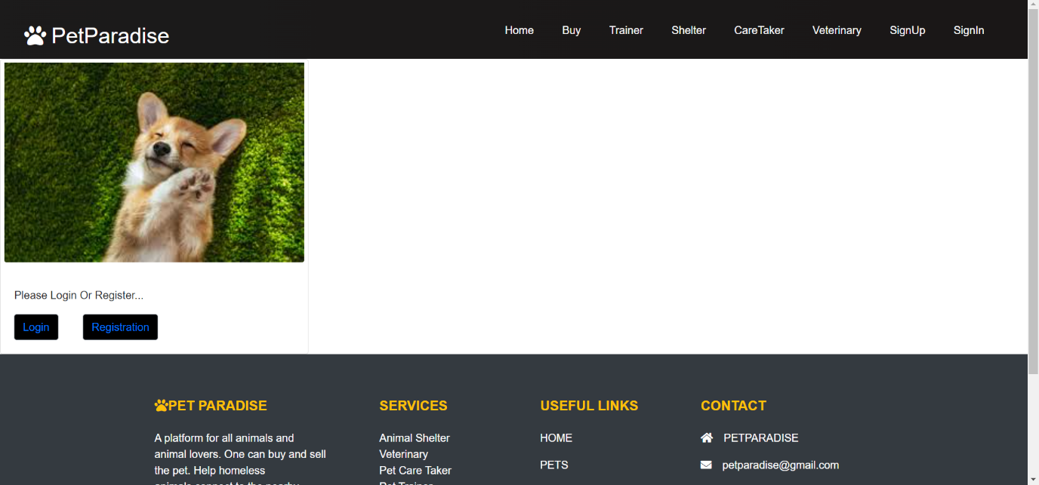

**5.1.5.2 Trainer Interface:**

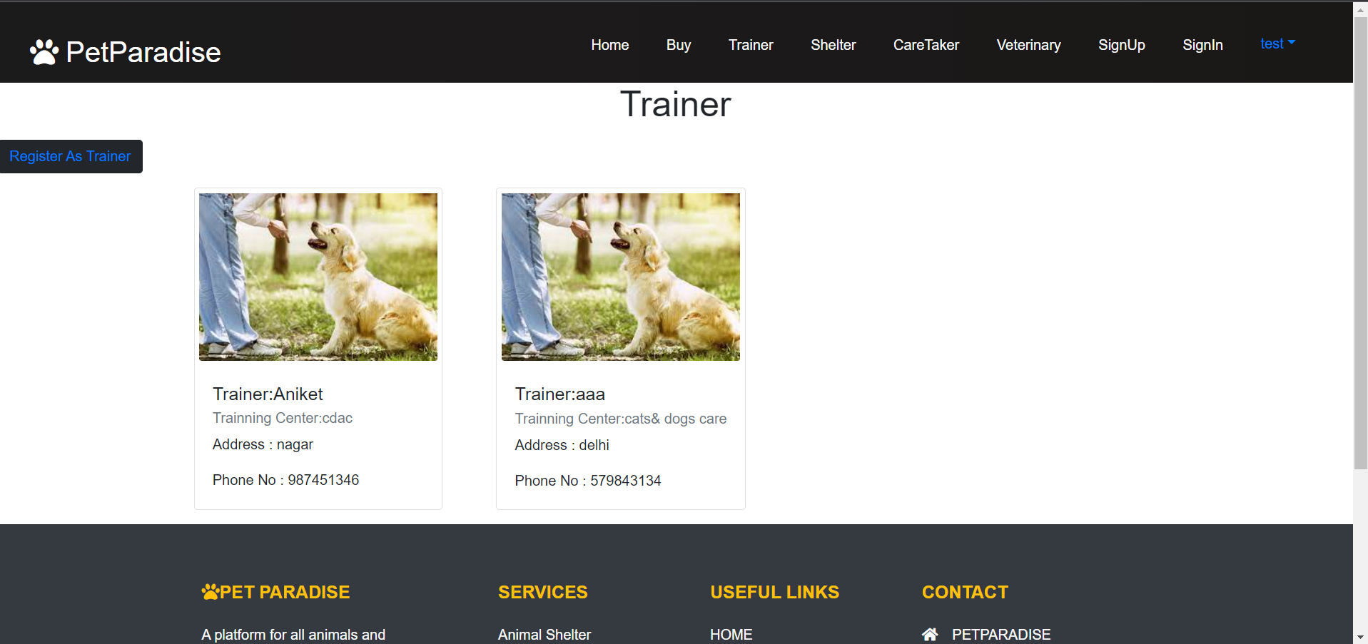

**Trainer Register:**

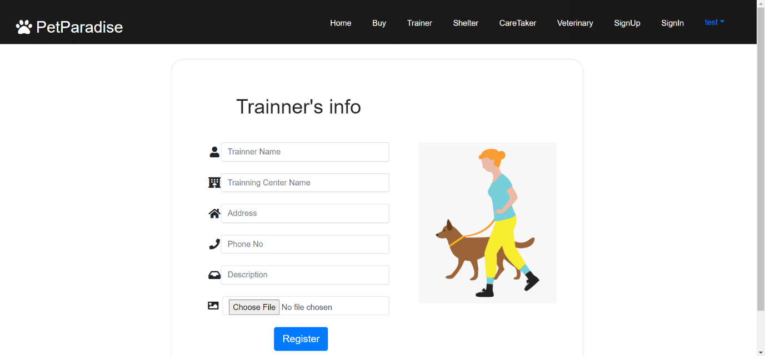

**5.1.5.3 Animal Shelter Interface:**

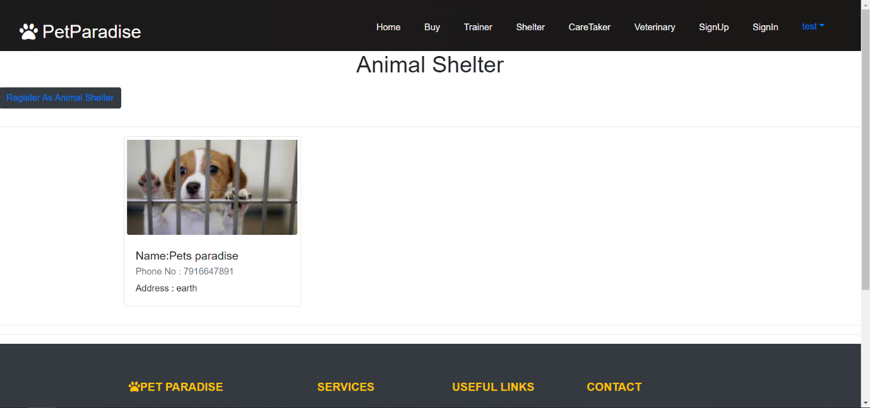

**Animal Shelter Register:**

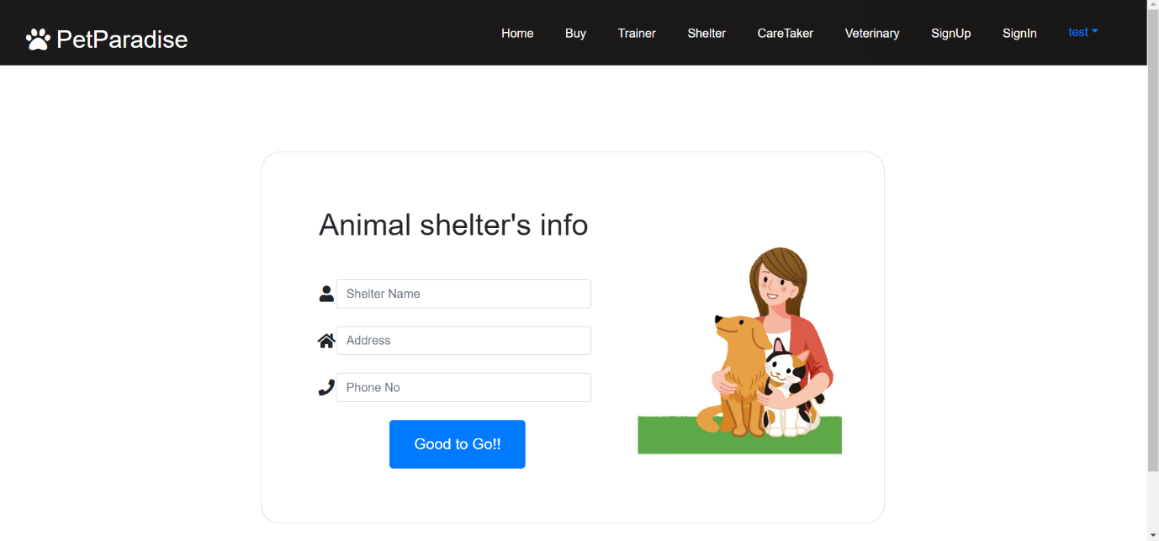

**5.1.5.4 Pet Caretaker Interface:**

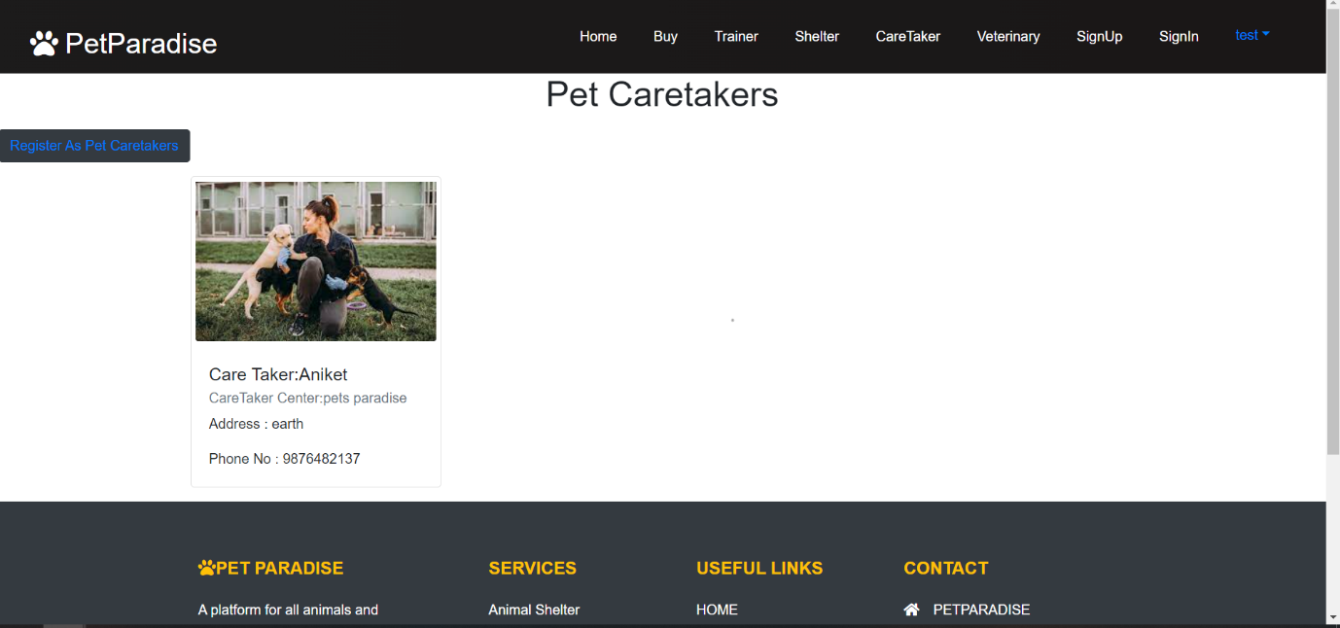

**Pet Caretaker Register:**

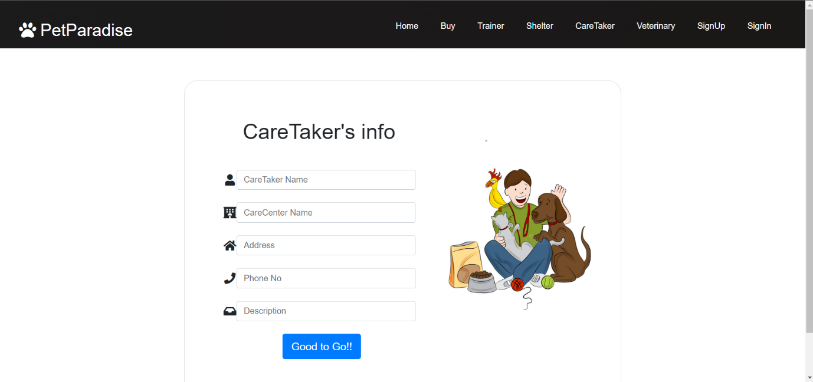

**5.1.5.5 Veterinary Interface:**

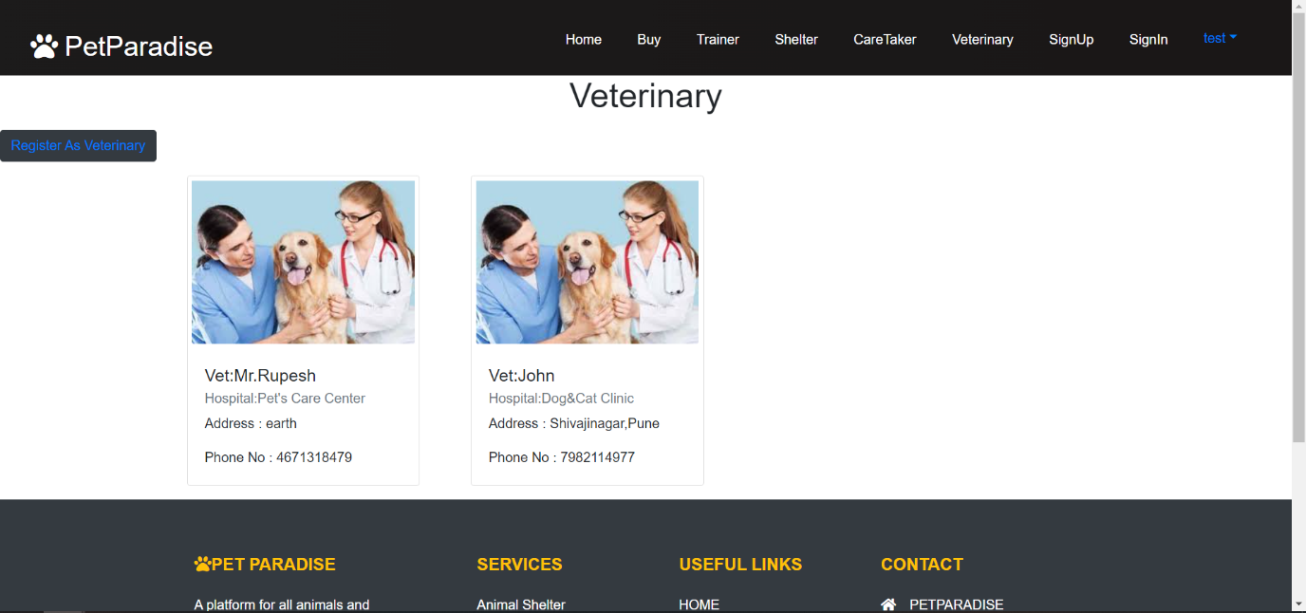

**Veterinary Register:**

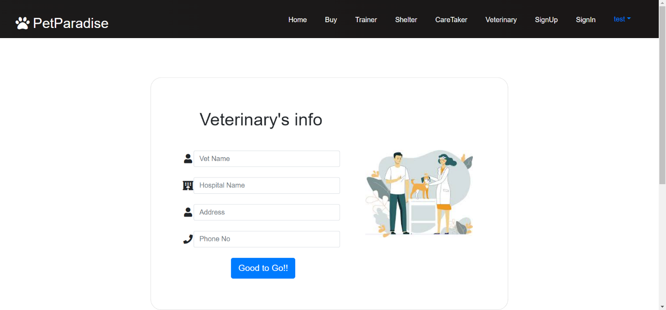

**5.1.6 Footer:**

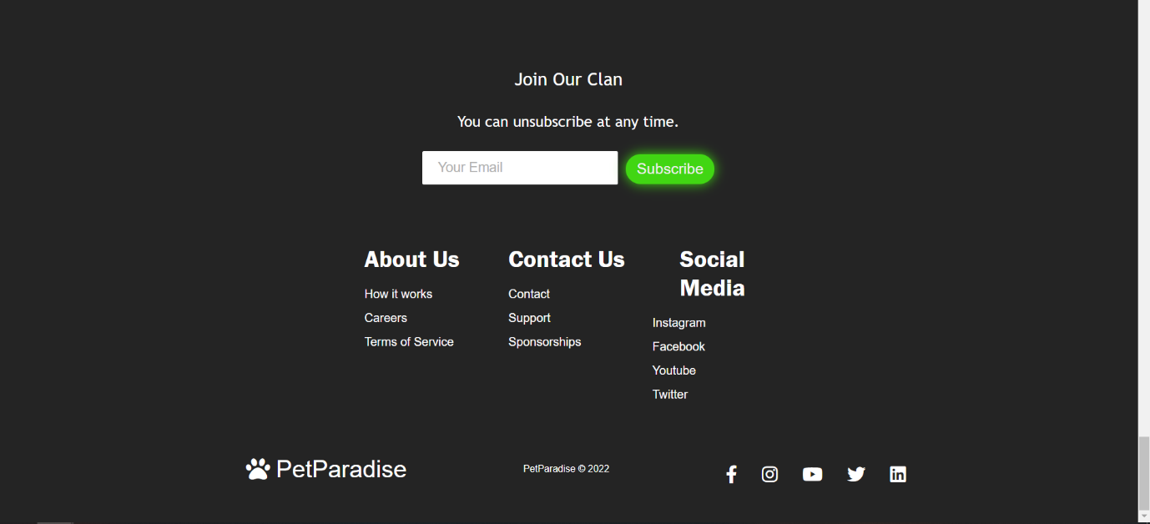

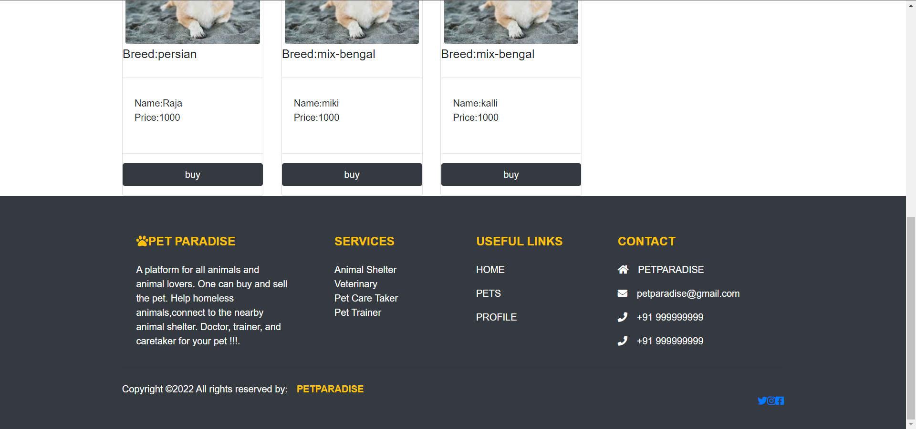

**Logout:**

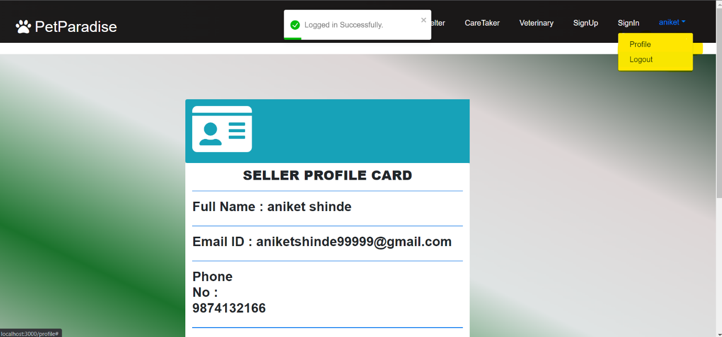

**6. TESTING:**

Software Testing is an empirical investigation conducted to provide stakeholders with information about the quality of the product or service under test, with respect to the context in which it is intended to operate. Software Testing also provides an objective, independent view of the software to allow the business to appreciate and understand the risks at implementation of the software. Test techniques include, but are not limited to, the process of executing a program or application with the intent of finding software bugs. It can also be stated as the process of validating and verifying that a software program/application/product meets the business and technical requirements that guided its design and development, so that it works as expected and can be implemented with the same characteristics.

Software Testing, depending on the testing method employed, can be implemented at any time in the development process, however the most test effort is employed after the requirements have been defined and coding process has been completed.

* 1. **Unit Testing:**

The primary goal of unit testing is to take the smallest piece of testable software in the application, isolate it from the remainder of the code, and determine whether it behaves exactly as you expect. Each unit is tested separately before integrating them into modules to test the interfaces between modules. Unit tests are typically written and run by software developers to ensure that code meets it design and behaves as intended. Its implementation can vary from being very manual (pencil and paper) to being formalized as part of build automation.

* 1. **Integration Testing:**

Integration testing, also known as integration and testing (I&T), is a software development process which program units are combined and tested as groups in multiple ways. Integration testing can expose problems with the interfaces among program components before trouble occurs in real- world program execution. There are two major ways of carrying out an integration test, called the bottom-up method and the top- down method. Bottom-up integration testing begins with unit testing, followed by tests of progressively higher-level combinations of units called modules or builds. In top-down integration testing, the highest- level modules are tested first and progressively lower- level modules are tested after that. In a comprehensive software development environment, bottom-up testing is usually done first, followed by top-down testing.

* 1. **Validation testing:**

At the validation level, testing focuses on user visible actions and user recognizable output from the system. Validations testing is said to be successful when software functions in a manner that can be reasonably expected by the customer. Two types of validation testing • Alpha testing is simulated or actual operational testing by potential users/customers or an independent test team at the developers' site. Alpha testing is often employed for off-theshelf software as a form of internal acceptance testing, before the software goes to beta testing.

• Beta testing comes after alpha testing. Versions of the software, known as beta version, are released to a limited audience outside of the programming team. The software is released to groups of people so that further testing can ensure the product has few faults or bugs. Sometimes, beta versions are made available to the open public to increase the

feedbackfield to a maximal number of future users

**6.4 Test cases:**

This software explains Test cases of Pet Paradise Web Application, testing is a critical element of software quality assurance and represents the ultimate review of specification, design and coding. Testing presents an interesting of a system using various test data. Preparation of the test data plays a vital role in the system testing. After preparation, the test data, the system under study is tested those test data. Errors were found and corrected by using the following testing steps and corrections are recorded for future references. Thus, series of testing is performed on the system before it is already for implementation.

The development of software systems involves a series of production activities where opportunities for injection of human errors are enormous. Errors may begin to occur at the very inception of the process where the objectives may be erroneously or imperfectly specified as well as in later design and development stages. Because of human in ability to perform and communicate with perfection, software development is followed by assurance activities ER Diagram for Buyer and Sellers.

**6.5 Objectives:**

The test plan for the system should support following objectives: Identify which features of the system will be tested.



Define the pass/fail criteria for each feature to be tested.

Specify the testing approaches that will be used during testing. Identify the deliverables of the testing process.

**6.6 Description:**

 **Test Steps -** List all the test execution steps in detail. Write test steps in the order in which they should be executed. Make sure to provide as many details as you can.

 **Test Data -** Use of test data as an input for this test case. You can provide different datasets with exact values to be used as an input.

 **Expected Result -** What should be the system output after test execution? Describe the expected result in detail including message/error that should be displayed on the screen.

 **Actual result -** Actual test result should be filled after test execution. Describe system behaviour after test execution.

 **Status (Pass/Fail) -** If actual result is not as per the expected result mark this test as **failed**. Otherwise, update it as **passed**.

 **Notes/Comments/Questions -** If there are some special conditions to support the above fields, which can’t be described above or if there are any questions related to expected or actual results then mention them here.

**6.7 Features to be tested**

This section outlines all the features that will be tested:

|  |  |  |  |
| --- | --- | --- | --- |
| **Type of User** | **Feature Identifier** |  | **Description** |
| Buyer | Case-1 | Register |  |
|  | Case-2 | View Pet |  |
| Seller | Case-3 | Add pet |  |
| Case-4 | Register |  |
| Case-5 | Display your pets |  |

**CASE 1 & CASE 4:** Register

Purpose: Test that users can register with the proper username and password

1. Visit Customer’s Sign Up web page
2. Enter First name, Last name, username
3. Enter Usertype 1 for seller and 0 for buyer
4. Enter password, e-mail, address, phone no & Aadhar no
5. Click Signup button

**CASE 3:** Add Pet

Purpose: Test that clicking add Pet button, Pet is getting added

1. Click Add Pet
2. Check whether the seller view pet shows the pet
3. Check if the quantity count is increased by one, if product is already in the view pet

**CASE 5**: Display pets in Buy

Purpose: Test that user can view all of the available pets

1. Click Place Order button
2. If user is not logged in redirecting toward login page
3. User can view all pets without login

**7. Future Scope:**

This Web Application has great future scope. A platform for all the animals and animal lover. For the homeless animals, we can post their picture so nearby animal shelter will accept that pet and will take care of those animals. Animal Lover can share their feeling post on our site.

We can also add the pet food and toys for sell and buy. We can book the appointment for trainer, caretaker and veterinary. We can also show the offer and services by trainer, caretaker and veterinary.

We can add filter to search the pet by breed, color, gender, prize, etc. We can also add online payment option.

DIGITAL VETERINARY & PET HEALTH Packaged Facts expects a great deal of activity and advancement in internet-based platform solutions that assist veterinary professionals, and digital health applications and devices that make it easier for pet owners to monitor their pets' health.

**8. Conclusion:**

* As conclusion, the main objective of pet Paradise system has been achieved that is Buying and selling of the pets
* This platform also helps in getting the contact details of animal shelter, pet caretakers, pet trainers, pet veterinary thus saving the valuable time and effort of pet lovers.

**9. References:**

The following books/links were used extensively

* Learning React: Modern Patterns for Developing React Apps
* Spring in Action (5th edition)
* https://www.springboottutorial.com/spring-boot-react-full-stack-crud-maven-application